# Zimbra Installation

## 3.1 Install Zimbra in CentOS 7 Server machine

**3.1.1** Edit selinux system configuration file enforcing to disabled



**3.1.2** Stop and disable the firewall service



**3.1.3** Stop and disable the postfix service



**3.1.4** Install required packages



Edit forward lookup zone file for mail forwarding access

Figure

5

.

7

:

Edit forward lookup zone file

**3.1.5** Make a new directory and switch to it



**3.1.6** Copy Zimbra installation file to the desktop and unzip it in new directory



**3.1.7** Switch to the unzip folder and run the installation file

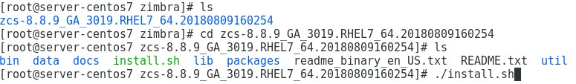

**3.1.8** Accept terms of the software license agreement and to use Zimbra’s package repository



**3.1.9** Select required packages to install



**3.1.10** Change hostname and domain name if required



**3.1.11** Configure unset values and continue process

Figure

5

.

18

:

Main menu

Figure

5

.

19

:

Store configuration



**3.1.12** Login to Zimbra and check Zimbra control status



Figure

5

.

20

:

Login to Zimbra

Figure 5.21: Zimbra control status

**3.1.13** Switch to Zimbra mail configured IP address using web browser and login

Figure

5

.

22

:

Zimbra admin console

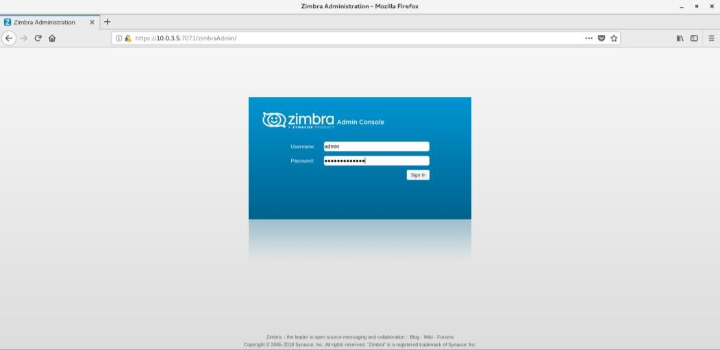

**3.1.14** Click Add Account to add user account

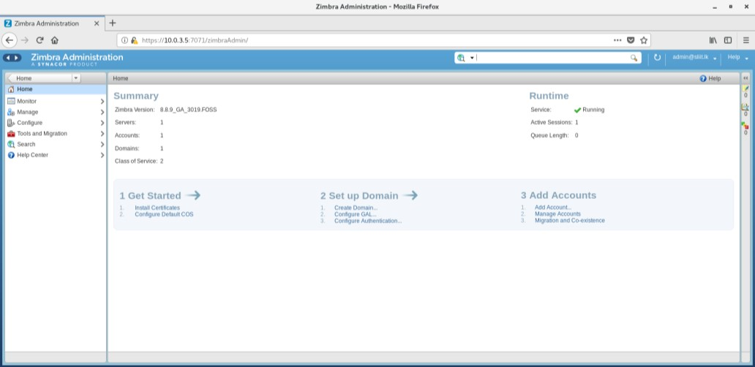

Figure 5.23: Zimbra home page **5.1.16** Add required details and create new user account

Figure

5

.

24

:

Add account

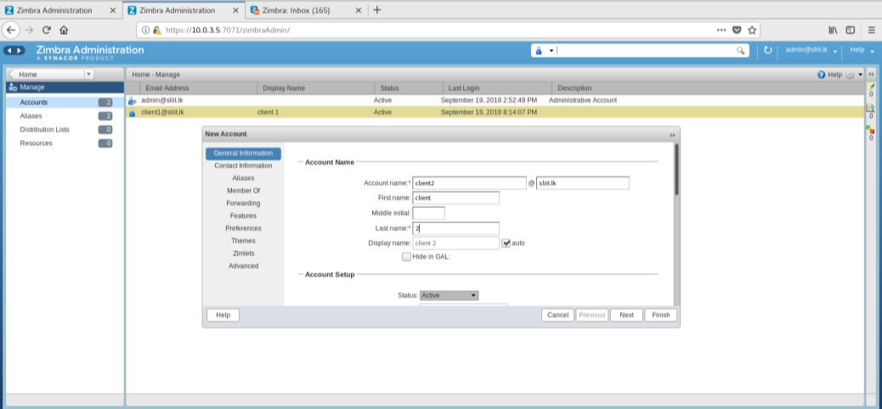

**3.1.15** Login to administrator mail account

Figure

5

.

25

:

Zimbra admin mail account

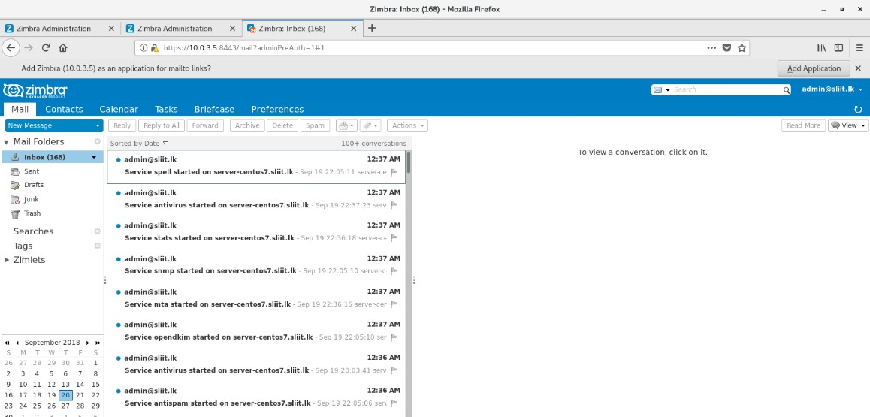

**3.1.16**

Login to client mail acco

unt

Figure

5

.

26

:

Zimbra client mail account

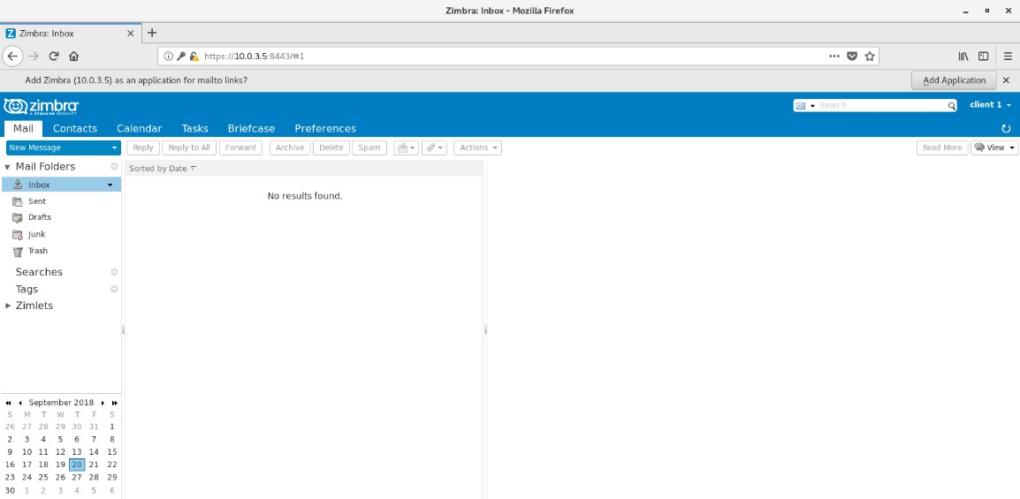

# References

**Annexes**

# Annex A: Adobe flash plugin installation



Figure A.1: Adobe release installation

# Annex B: Check hostname and details

Figure

B

.

1:

Check hostname

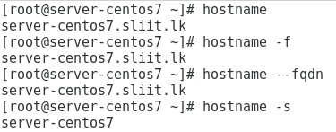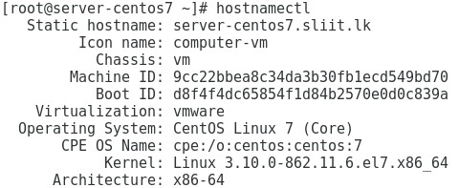

Figure B.2: Check hostname details